4: Integrating Issue Checklists to the tasks created from Issue Templates

Plugin Issue Templates for Jira doesn’t allow to add checklists from Jira Checklists plugin. The problem was solved with the help of Jira Automation rules.

Setup Instructions:

1. Install extension – Issue Checklists Free
2. We should already have installed and configured – Issue Templates for Jira
3. We should have created task-template with ready checklists in the project Templates (Issue Templates plugin)

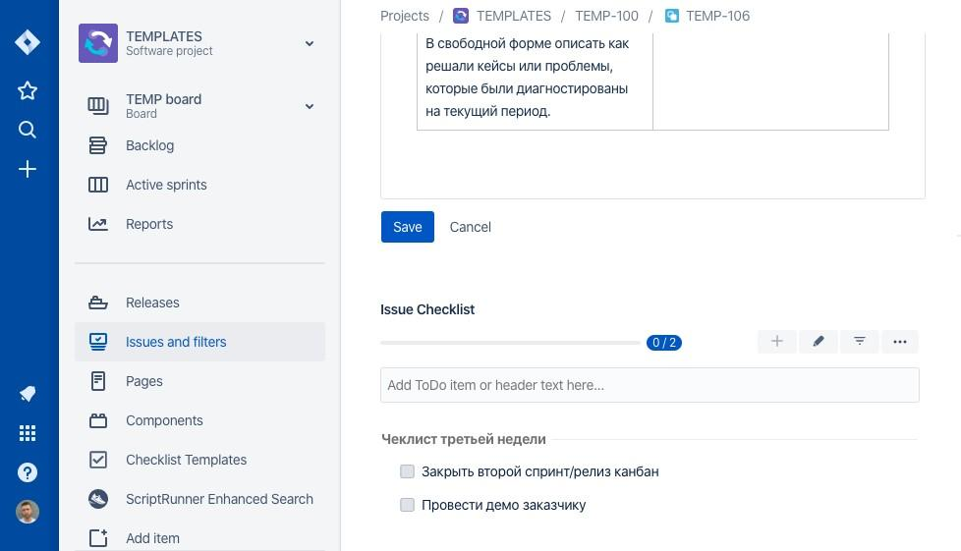

In our next step, we need to go to the project in which we are going to use the task with checklists created from a template. Go to Project Automation in project settings.

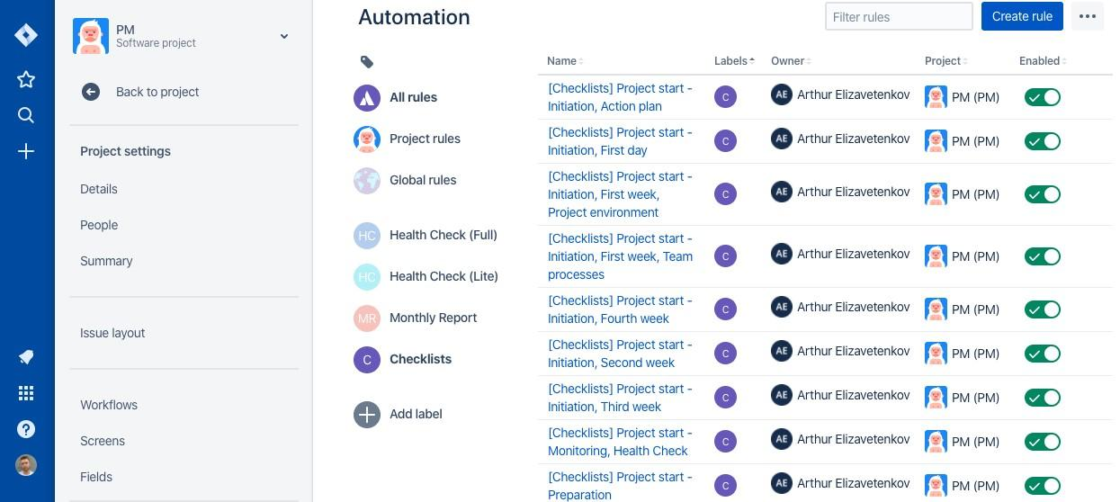

Now we need to configure Automation Rule – a condition according to which, when creating a new task in a project, by a certain label a checklist will be added to it. Set Automation Rule as follows:

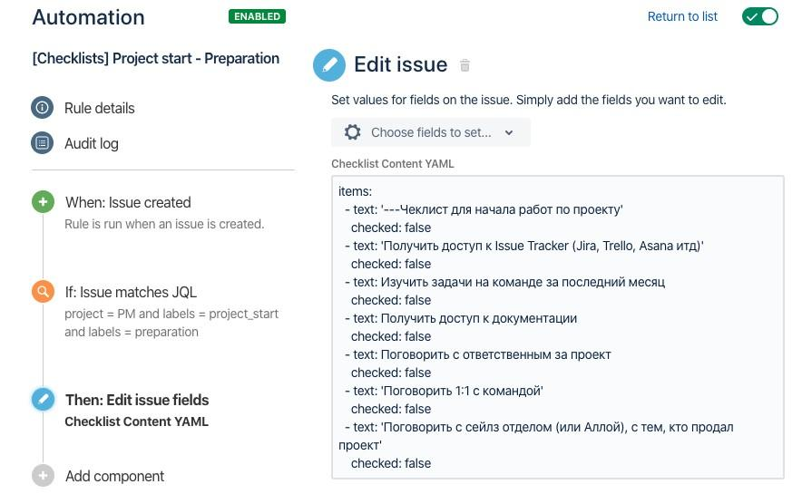

Trigger - Issue created

Condition - JQL definition is equal to the project’s title + task label project = PM and labels = project_start and labels = preparation)

Action - Edit issue for value Checklist Content YAML

In the Checklist Content YAML field, insert the created checklist from the parent task with the checklist.

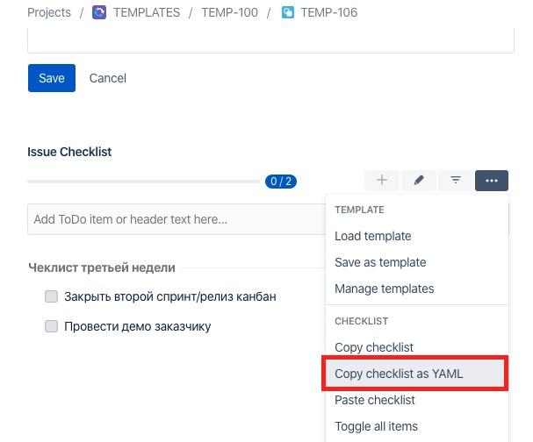

Next, save and turn on Automation Rule

Picture 84

Now when creating task from the issue template Create from Template we will have a task created in a selected project + checklists attached to it.